H.T No
Regulations:
A18


Sreenidhi Institute of Science and Technology
(An Autonomous Institution)
Code No: 7BC03 Date: 07-Jan-2019 (FN)

B.Tech I-Year I-Semester End External Examination, Dec-2018/Jan-2019 (Regular)
ENGINEERING MECHANICS (ME)

Time: 3 Hours Max.Marks:75

Note: a) No additional answer sheets will be provided.
b) All sub-parts of a question must be answered at one place only, otherwise it will not be valued.
c) Missing data can be assumed suitably.

Part - A Max.Marks:25

Answer all QUESTIONS.

1. | Determine the magnitude of the two forces such that if they act at right angles, their resultant is 10N. But if they act at 60ᵒ their resultant is 13N. | [3M]
2. | Define truss and mention the assumptions for it’s analysis. | [3M]
3. | State and explain pappu's theorem-I | [3M]
4. | Define Polar moment of inertia and state its significance. | [3M]
5. | Compare and contrast the rectilinear and curvilinear motions. | [3M]
6. | What differences exist between impulse and momentum? | [2M]
7. | List some supports in structures and mention their reactions in free body diagrams. | [2M]
8. | What is meant by rolling friction? | [2M]
9. | Distinguish between impulse and momentum? | [2M]
10. | Determine M.I of an isosceles triangle with base 150mm and sides of 125mm about its base. | [2M]
Part – B Max.Marks:50
ANSWER ANY FIVE QUESTIONS. EACH QUESTION CARRIES 10 MARKS.

11. |  | Consider the 75 kg crate shown in the Fig.1. This crate was lying between two buildings and it is now being lifted onto a truck, which will remove it. The crate is supported by a vertical cable, which is joined at A to two ropes which pass over pulleys attached to the buildings at B and C. Determine the tension in each of the ropes AB and AC.  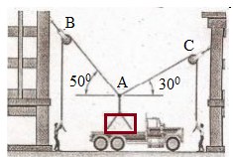Fig.1 | [10M]
12. |  | Determine the force in each member of the truss shown in Fig.2. Indicate whether the members are in tension or compression.  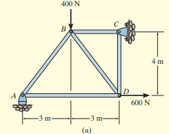Fig.2 | [10M]
13. |  | The gravity wall is made of concrete which is shown in Fig.3. Determine the location ( ) of the center of mass G for the wall.  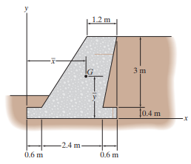Fig.3 | [10M]
14. |  | Determine the moment of inertia of the composite area shown in Fig.4 about the  y-axis.  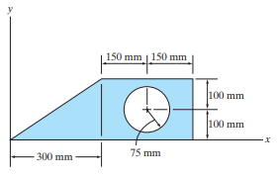Fig.4 | [10M]
15. | a) | Discuss the rigid body translation. | [5M]
 | b) | Two stones A and B are projected from the same point at inclinations of 45⁰ and 30⁰ respectively to the horizontal. Find the ratio of the velocities of projection of A and B if the maximum height reached by them is the same. | [5M]
16. |  | In Fig.5, if the coefficient of kinetic friction between the 100-kg crate and the plane µ_{k}=0.25, determine the compression x of the spring required to bring the crate momentarily to rest. Initially the spring is un-stretched and the crate is at rest.  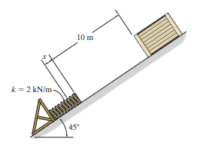Fig.5 | [10M]
17. |  | Explain about:
 | a) | Method of joints. | [5M]
 | b) | The working principle of screw jack. | [5M]
18. |  | Discuss about:
 | a) | Transfer formula for mass moment of inertia. | [5M]
 | b) | Conservation of linear momentum. | [5M]

-- 00 -- 00 –

